Candidate Name: |  | Class | Registration No
NATIONAL JUNIOR COLLEGE

SH2 PRELIMINARY EXAMINATIONS
Higher 1

CHEMISTRY | 8872/01
Paper 1 Multiple Choice | Fri 17 September 2010
 | 50 minutes

INSTRUCTIONS TO CANDIDATES
Do not open this booklet until you are told to do so.
Write your name, class and registration number in the spaces provided at the top of this page as well as on the optical mark sheet provided.
Shade the index number in a 5 digit format (12345) on the optical mark sheet.
Row 1: Year of admission
- for SH2 7 for IP
Row 2: Level on admission
5 for SH2 3 for IP

Rows 3, 4 and 5: Last 3 digits of registration number

Eg: Reg No 0905648 = 95648 Reg No 0703093 = 73093

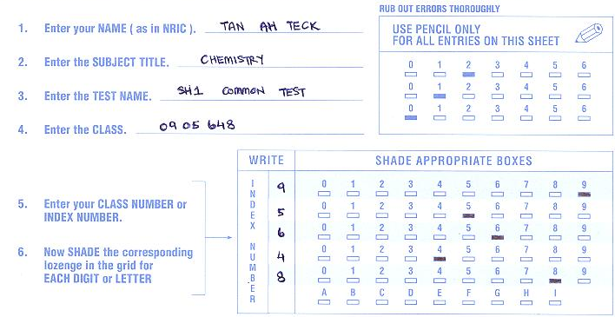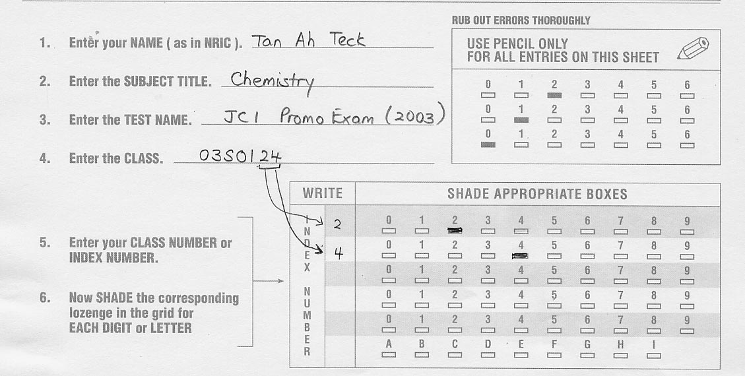
There are 30 questions in this paper. Answer ALL questions.
For each question, there are four possible answers, A, B, C and D. Choose the one you consider correct and record your choice in 2B pencil in the optical mark sheet.
Submit both the optical mark sheet as well as the question paper at the end of the examination.

Section A
This question paper consists of 11 printed pages (including this page)

For each question in this section, there are four possible answers A, B, C and D. Choose the one you consider to be correct.

1. Which of the following does not contain 4 moles of hydrogen atoms at standard temperature and pressure?

A 22.4 dm³ of methane
B 36 g of water
C 2 moles of hydrogen gas
D 28 g of ethane

2. 1.08 g of an oxide MO of a metal M was dissolved in excess sulfuric acid. 25.0 cm³ of 0.10 mol dm⁻³ potassium dichromate solution was required to oxidize M²⁺ to M³⁺.

What is the relative atomic mass of M?

A 52
B 56
C 64
D 72

3. An element Y forms an ion Y^{n+}. The atom Y and the ion Y^{n+} have the same

A size
B number of protons
C number of electrons
D electronic configuration

4. Which one of the following shows the electronic arrangement of the strongest reducing agent?

A 1s² 2s² 2p⁵
B 1s² 2s² 2p⁶ 3s²
C 1s² 2s² 2p⁶ 3s² 3p⁵
D 1s² 2s² 2p⁶ 3s² 3p⁶ 4s²

5. The graph below shows the ionic radii of five consecutive elements, P, Q, R, S and T in Period 3.
Element
Ionic radius
P
T
Q
R
S

All of the following statements are true except

A Ions of P to S are isoelectronic.
B Elements P to S exist as giant structures.
C There are 3 unpaired electrons in Element T.
D Element P has higher melting point than Element Q.

6. Which of the following pairs of compounds have the same shape?
A AlCl₃ and PCl₃
B NH₃ and BCl₃
C H₂O and H₂Se
D CO₂ and SO₂

7. Which of the following statements about the properties associated with ionic and covalent bonds is correct?

A Ionic bonds and covalent bonds may both occur in the same compound.
B All covalent compounds cannot conduct electricity in their aqueous state.
C The only covalent compounds with high boiling points are those in which hydrogen bonds exist.
D Any covalent compound that contains both oxygen and hydrogen in its molecule forms hydrogen bonds.

8. Tetrafluoroethene, CF₂=CF₂, is produced by the reaction

2CHClF₂(g) → CF₂=CF₂(g) + 2HCl(g) ΔH_{reaction}

Bond energies (in kJ mol⁻¹) involved in the reaction are given below:

C-H p
C-Cl q
C-F r
C=C s
H-Cl t

Which of the following calculations will give the value of ΔH_{reaction}?
A q – s – 2r – p
B s + 2t – 2p – 2q
C 2p + 2q – s – 2t
D 2p + 2q – s – 2t – 2r

9. Which of the following definitions is not correct?
A First ionization energy is the energy taken in when one mole of valence electron is removed from one mole of its gaseous atoms to form one mole gaseous singly-charged ions.
B Lattice energy is the heat taken in when one mole of ionic solid is formed from its gaseous ions under standard conditions.
C The standard enthalpy change of neutralization is the heat evolved when one mole of water is formed from the reaction between an acid and an alkali under standard conditions.
D The standard enthalpy change of combustion is the heat evolved when one mole of a substance is completely burnt in excess oxygen under standard conditions.

10. Two first order reactions were started at the same time. Reaction A had an initial concentration of 1 mol dm⁻³ and a half-life of 20 minutes. Reaction B had an initial concentration of 4 mol dm⁻³ and a half-life of 10 minutes. After how long would the concentration of the reactants in the two reactions become equal?

A 15
B 35
C 40
D 50

11. A researcher carried out a series of experiments to determine the order of reaction with respect to C and D. The results are summarised in the table below.

C + D → E

Experiment | [C] / mol dm⁻³ | [D] / mol dm⁻³ | Rate / mol dm⁻³ s⁻¹
1 | 0.5 | 0.5 | 0.02
2 | 1.0 | 0.5 | 0.04
3 | 0.5 | 1.0 | 0.02

What is the unit for the rate constant, k in the overall rate law?

A s⁻¹
B mol⁻¹ dm³
C mol⁻¹ dm³ s⁻¹
D mol⁻² dm⁶ s⁻¹

12. The equation below gives the decomposition of HI.

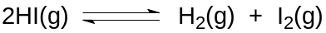
At time t₀, 0.500 moles of HI was placed in a 250 cm³ vessel at 445°C and equilibrium was established at time t₁ as shown in the diagram below. At time t₂, the system was subjected to a change and equilibrium was re-established at time t₃. Which of the following would give rise to the changes observed at time t₂?

No of moles
t₀
t₁
t₂
t₃
time
0.500
HI
H₂, I₂
HI
H₂
I₂

A Increasing the temperature of the system.
B Removal of H₂ gas as soon as it is formed.
C Addition of more HI at the same temperature.
D Addition of sodium thiosulfate solution at the same temperature.

13. A major source of carbon monoxide comes from the reaction between steam and carbon.
∆H = +ve

Which of the following conditions favour the highest proportion of CO in the equilibrium mixture?

Temperature Pressure
A Low High
B Low Low
C High Low
D High High

14. Which one of the following pairs will give a buffer solution when the two solutions are mixed?

A 50 cm³ of 0.10 mol dm⁻³ NaHCO₃ and 100 cm³ of 0.10 mol dm⁻³ HCl.
B 50 cm³ of 0.10 mol dm⁻³ NaHCO₃ and 100 cm³ of 0.10 mol dm⁻³ NaOH.
C 50 cm³ of 0.10 mol dm⁻³ NaHCO₃ and 100 cm³ of 0.10 mol dm⁻³ NaOH.
D 100 cm³ of 0.10 mol dm⁻³ NaHCO₃ and 100 cm³ of 0.10 mol dm⁻³ H₂CO₃.

15. The curve below shows a titration reaction between 10 cm³ of a weak acid HClO of concentration 0.5 mol dm⁻³ and NaOH of concentration 1.0 mol dm⁻³.
Vol of NaOH added / cm³
pH
w

Which of the following statements is true about the titration reaction?
A The chemical species present at point W are ClO⁻, NaOH and H₂O.
B The pH value at equivalence point is 7.
C The volume of NaOH required for complete reaction is 10 cm³.
D A suitable indicator for this titration is phenolphthalein, which changes from colourless to pink.

16. Which of the following statements about Period 3 elements is true?

A The melting points decrease in the order P > S > Cl > Ar.
B On heating in air, sulfur burns with a blue flame to give colourless SO₂ gas.
C The electrical conductivity increases from sodium to silicon.
D Aluminium burns in oxygen to form a covalent oxide Al₂O₃.

17. A mixture of 10 cm³ of methane and 10 cm³ of ethane was sparked with an excess of oxygen. After cooling to room temperature, the residual gas was passed through aqueous potassium hydroxide of concentration 0.100 mol dm⁻³. What is the volume of aqueous potassium hydroxide required to react with the residual gas?

A 12.5
B 13.4
C 25.0
D 30.0

18. Which of the following substances has the highest boiling point?

A CH₃(CH₂)₂CH₃
B (CH₃)₂CHCH₃
C CH₃(CH₂)₃CH₃
D (CH₃)₄C

19. How many different alkenes are formed when 3-methylbutan-2-ol reacts with excess concentrated sulfuric acid at 170ºC?

A 2
B 3
C 4
D 5

20. Oxidation of an alkene X gives a diol which cannot be further oxidized. Which of the following could be X?

A CH₃CH=CH₂
B CH₃CH=CHCH₃
C CH₃CH=C(CH₃)₂
D (CH₃)₂C=C(CH₃)₂

21. Which one of the following statements explains best why fluoroalkanes are the least reactive halogenoalkanes?

A Fluorine is much more electronegative than carbon.
B The F– ion is the most stable halide ion.
C The C–F bond is the strongest carbon–halogen bond.
D The C–F bond is the most polar carbon–halogen bond.

22. Which one of the following is formed when an excess of CH₃Br reacts with (CH₃CH₂)₂NH?

A
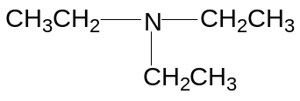

B
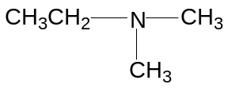

C
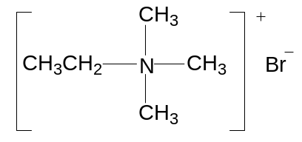

D
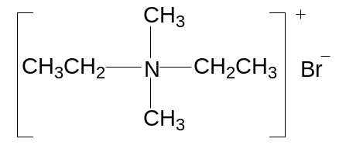

23. The Williamson’s ether synthesis involves a nucleophilic substitution of an organic halogen compound. Which of the following the reagents can be used for the synthesis of methoxyethane, CH₃CH₂OCH₃ starting from CH₃CH₂Br?

A NaOH in CH₃OH
B CH₃OH with Na
C CH₃CH₂O⁻K⁺
D CH₃OH

24. Which of the following statements about the reaction scheme is incorrect?

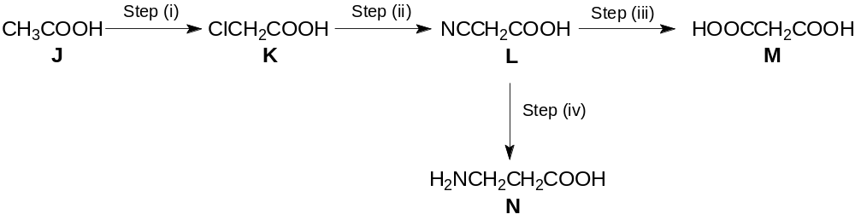

A Step (i) could be achieved using chlorine in the presence of heat.
B Step (ii) could be achieved using aqueous potassium cyanide.
C A reduction reaction is involved in the reaction scheme.
D An acid hydrolysis reaction is involved in the reaction scheme.

25. The scheme shows the formation of phenylmethanol from the starting compound, 1-phenylpropan-1-ol

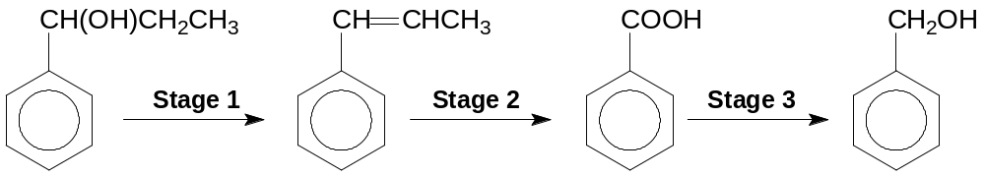

What are the reagents required for each stage?

 | Stage 1 | Stage 2 | Stage 3
A | Excess concentrated H₂SO₄; heat | Acidified K₂Cr₂O₇ ; heat | H₂(g) / Pt(s)
B | Excess concentrated H₂SO₄; heat | Acidified K₂Cr₂O₇ ; heat | LiAlH₄ in dry ether
C | Excess concentrated H₂SO₄; heat | Acidified KMnO₄ ; heat | H₂(g) / Ni(s) ; heat
D | Al₂O₃ ; heat | Acidified KMnO₄ ; heat | LiAlH₄ in dry ether

Section B

For each of the question in this section one or more of the three numbered statements 1 to 3 may be correct.

Decide whether each of the statements is or is not correct (you may find it helpful to put a tick against the statements which you consider to be correct).

The response A to D should be selected on the basis of

A | B | C | D
1, 2 and 3 are correct | 1 and 2 only are correct | 2 and 3 only are correct | 1 only is correct

26. In which pair is the bond angle in the first species larger than that in the second species?

1 H₂O, H₂S
2 CO₂, CS₂
3 CH₄, CCl₄
(D)

27. The equilibrium constant K_{c} for the reaction

is found to vary with temperature as shown in the diagram below.
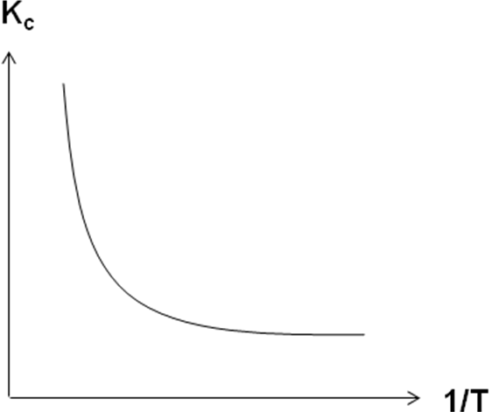

Which of the following conclusion(s) can be drawn from this information?
1 The production of U and V is an endothermic process.
2 The equilibrium mixture contains a higher proportion of R at higher pressures.
3 The addition of a catalyst will increase the value of the equilibrium constant K_{c}.
(B)

28. Which of the following shows the correct trend across Period 3 elements?

1 Electronegativity of the elements increases.
2 Ionization energy of the elements increases.
3 Melting point of the oxides increases.
(B)

29. Ionone, shown below, is a compound responsible for the smell of raspberries.

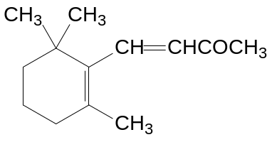

The type of reactions that ionone can undergo include

1 Electrophilic substitution
2 Nucleophilic addition
3 Reduction
(C)

30. What are the functional groups present in the naturally occurring compound, lovastation?

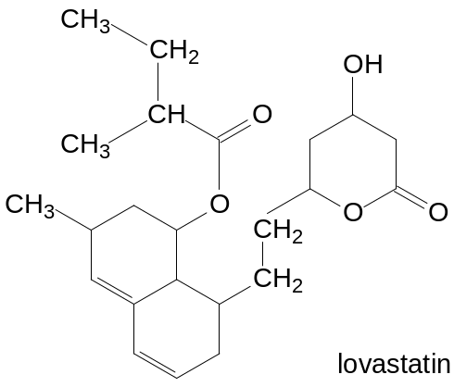

- alkene
- ketone
- tertiary alcohol
(D)

End

